ANGULAR 7

Angular is java script frame work, which makes you able to creat reactive single page applications(SPA).

This is leading front end development frame work.

Which is regularly updated by angular team of google.

Angular 7 is completely based on components.

It consists of several components forming a tree structure with parent and child structure.

Actually angular 7 is a type script based open-source full stack web applications.

What is a single page application?(SPA)

A Single page application is a web application or website which provides users a very fluid.

Reactive and fast experiences similar to desktop applications.

It contains menu, buttons and blocks when users clicks a button it dynamically rewrites the current page rather than loading entire new page from server.

DIFFERENCE BETWEEN ANGULAR JS AND ANGULAR :--

|  |  |
| --- | --- |
| ANGULAR JS  Angular js is a common and popular name of the first version of angular 1.0.  Angular js is a javscript based open source of front end web framework.  Angular js uses the concept of scope or controller  Angular js has a simple syntax and used on HTML  Pages a long with the source location.  Angular js is a simple javascript file which is used with HTML pages and doesnot support the features of a server side programing language.  Angular js doesnot support the dynamic web pages | ANGULAR  Angular is common and popular name of the Angulars verosn beyond 2+.  Angular is a type script based open source full stack web application.  Instead of scopr or controller ,angular uses hierarchy of components as its primary architectural characteristic.  Angular uses the different expressions “[]”for property binding and”()” for event binding.  Angular use of Microsoft typescript languages.  Which provides class based object oriented programing.startic typing,generic etc,which are the features of a server side programing language.  Angular supports dynamic web page. |

ANGULAR 1 :- was initially released in 2010, it was the first angular version,

**DURGASOFT TUTORIAL BY SAI SIR:--**

Topics:-

1 ) What is angular?

Angular is a client-side “type script frame work” for developing dynamic web-apps.

Web> internet

Apps>applications

Websites> gmail.com, fb.com, yahoo.com

*What is Dynamic Applications?

(Data/information in website changes w.r.t 3 aprameters)

*Time (News update)

*Locations(weather report)

*user(gmail/facebook)

NOTE:

What is Angularjs and Angular?

Angularjs is a javascript framework

Angular is a typescript frame work

Angularjs is not a first version of angular.

Angular is separate framework and it is not related to angularjs

For EX:-

JAVA(oop)

.NET(oop)

(OOP by using we are developing computer applications )

This two languages are object oriented programing languages.

But java is a separate programing language and .net is separate programing language.

In both languages we have OOP in both we have abstraction, encapsulation, inheritance, polymorphism.

But both are separate programing languages.

*In the same way Angularjs is a javascript Framework& Angular is a Typescript Frame work,both are not same.

***Latest version of Angular is 8.(MAY 28,2019).

Angular is very flexible,simple and easy with more features and good performance.

*What is the difference beteen angularjs and angular ?

Both are using for developing dynamic web applications but angularjs is based on jasvascript frame work and angular is based on typescript framework.

For Developing website we are follow 3 tire architect.

CLIENT< --- >SEREVER< --- >DATABASE< ----- >

|  |
| --- |
| DATABASE  [TIER-3,STORAGE  (BACK-END)]  Database is nothing but the backend storage  (oracle)  Mysql,sql server |

.

Serverside techn comm.with DB w.r.t time,location,user

[tier 1-> presentation frontend] [Tier2- Middleware(business-logic)]

|  |
| --- |
| CLIENT |

|------request-------------🡪

|  |
| --- |
| SERVER  JAVA  .NET  PHP  PYTHON |

response

CLIENT IS NOTHING

BUT BROWSER

(BROWSER WILL MAKE A

REQUEST TO THE SERVER FOR

ACCESING THE WEBSITE )

***This is 3 Tier Architecture for developing webapplications.

In this:-

HTML[ Display the data]

CSS[it will gives stylish attraction to data]

Javascript [its having programing capability]

TYPESCRIPT [typescript is superset javascript]

We can do better progrsmming when compared to javascript.

*why we can do better programing in typescript compared to javascript?

Beacause of its having more features compare to javascript.

2)Where we use angular?

3)What is type script?

TYPESCRIPT [typescript is superset javascript]

*Which is developed by Microsoft company ,which is open-source.

*Which Is strictly type language and supports

Typed language means it supports data-types/classes/interfaces/inheritance etc.

USES:--

We can do better progrsmming when compared to javascript.

*why we can do better programing in typescript compared to javascript?

Beacause of its having more features compare to javascript.

TYPESCRIPT IS NOTHING BUT A SCRIPTING LANGUAGE.Which is same likejavascript.which is used to do program in webpage.

More programing capability,in html web page.

4)What is Framework?

Angular is a typescript frame work.

Frame Work :--frame work means [ run time environment+runtime library ]

Library means[pre-defined modules/classes/functions].

Environment means[Execute our coding as per typescript standards]

**Angular is an application platform

Application platform means multiple technologiescan be used for dynamic web apps

ANGULARJS VS ANGULAR:--

*performance is 5 times better.

*Cross platform (Which means one application can run different devices pc/laptop/mobiles/tabs etc)

*Easy to implement

*More features of type script compared to javascript.

BUILDING BLOCKS OF ANGULAR:-

*components(everything is webpage is a component)

*modules(Grouping of related coding)

*templates(views by html/css)

*decoraters(Extra information to angular framework)

*services(reuable coding in angular)

COMPONENTS:--

*MAINSECTION*

Header section

FOOTER SECTION

LEFT

SECTION

Root component

Main section component

Left section component

Footer component

Headercomponent

This are everything represents components.

Every component have a view.

Header component Header view(HTML/CSS)

Left section component Left section VIEW (HTML/CSS) uses

Main section component Main section VIEW (HTML/CSS)services

Footer section component Footer section view(HTML/CSS)

TYPESCRIPT:- It is a superscript of javascript

What do you mean superscript?

By using typescript we can do programming with many features compare to javescript.

**NOTE:--

Every browser (google,chrome,Mozilla,firefox,opera,safari).

Every browser supports HTML/CSS/JAVASCRIPT.

Then

***Typescript in browser?and how to make browser understand Typescript?

For this process we have to use Transpilation, this ( transpilation converts typescript into javascript) and then its executed in the browser.transpilation is done in server only.

ADVANTAGE:--

***less coding with more functionality in webpage***

How to build an angular application using components?

For ex:-

We have

Header section-component🡪VIEW(html/css)-🡪SERVICES

Main section –component🡪VIEW(html/css) )-🡪SERVICES ROOT COMPONENT.

Left section-component🡪VIEW(html/css) )-🡪SERVICES

Footer section-component🡪VIEW(html/css) )-🡪SERVICES

In This every section coding is internally done with the COMPONENTS.

So componets are building blocks of our HTML web Page.

*In this every section is a component

**Every component have a VIEW,in each view represented in html or css.

***all this components will be under ROOT COMPONENT.

****in this every component uses different SERVICES.

*****this components we are going to represent it has classes in angularjs coding.

SERVICES :- services are nothing but reusable coding in a web pages.

CLASS:-

* Class is the collection of data members and methods (or) collection of variables and functions.

*every component is nothing but a class.every component has a view(html/css),different components use a different different services to meet the view to more interactive to the user.

*This is called as component page development using angular.

*Uses of component base web application development advantages is parallel development is possible

*It means one person can work on header section and another person can work on the main section and another on left and footer section.

*By using this we can do multiple parallel development by multiple users.we can complete the web app. Is very quickly

* one more advantage is building a dynamic web application by using components.

*Pre requisites for Angular?

HTML,CSS,JAVASCRIPT

NOTE:--

*HTML and CSS Doesnot have programing capability.

*HTML mainly concentrates on how to display the data in a web page.

*CSS by using this we can make HTML data more stylish and interactive.

What is type script?

Every one says type script is a superscript of javascript.

What is that mean technically?

By using javascript whatever we can do it is possible in typescript and we can also do more than that.

FOR EX:-- let us assume that this is what capability of scripting language.

typescript

Javascript commonly we use to make programming in a webpage.

**What is that we can do extra with typescript?

Typescript provides OOP’s(object oriented programming) concepts

Like

We have Classes,Interfaces,etc (like JAVA and .NETprogramming languages)

[ OOP,s concept – Abstraction, Encapsulation, Inheritance, Polymorphism ].

**In Javascript we don’t have this oop,s concept, we can call this “SUBSET”.**

NOTE:-- Every typescript is converted to javascript.

(.ts --------> .js)

Why this conversion?

Reason( Till Today every browser understands only javascript).

That’s why before excuting your type script in browser we have to convert javascript.

For that conversion we are using Transpilation.

TRANSPILATION:-

It is the process of converting typescript into javascript.

**What are the other scripting languages which compiles to javascript**

1)DART

2)PURESCRIPT

3)COFFESCRIPT

4)CLOJURESCRIPT

5)SCALA.JS

6)REASON (BY FACEBOOK)

7)HAXE

8)NIM.

All this scripting languages internally converted into javascript and giving to the users.

NOTE:--

Who will do the transpilation process?

Before Angular is executed for user in browser,in server- only TS is converted to JS.

NOTE:--

Angular frame work is completelyRe- written in typescript.

Typescript allows us to write both client and server-side scripts.

Advantage is, Building web-applications quick and fast.

*Prequisites for typescript:::

Javascript

Oop concept of PL.

Introduction and History of Typescript:-

**Javascript is a client side scripting language for programming in HTML Webpage.

**Node.JS is server-side Scripting Language.

**In Enterprise-application,javascript is complex and difficult to maintain

**Typescript is est alternative for this features like 0bject0riented, Type checking etc.

What is the definition of Typescript?

*It was invented by Anders Hejlsberg, at Microsoft, AT MICROSOFT.(1996).

*Typescript is javascript for developi ng web-applications,it is 0bject0riented, compiled language and typed language.

*javascript with extra features we are going to get Typescript.

Features of Typescript:--

*Typescript is nothing bu javascript only(but converted process).

*Supports for javascript Libraries.

*javascript to typescript(every javascript can be converted into typescript).

*Portable(Browser,OS,Devices)

*OO scripting language

*Typedscripting language

*Classes and modules

*Generics and type annotations.

ADVANTAGES:--S

*compiled scripting language.(Compiler,Errors)-(Transpiller),compiler is known as transpiler.

*Typedscripting language(Datatypes).

*Support other Javascript libraries.

*supports oop like Classes,interfaces,inheritance ect.

How to setup Environment for Typescript :::::::::

1)In windows operating system : : : :

**Typescript is a opensource technology.(free os cost)

**It can run on any web browser, any OS on any Device and alsoon any Server_Machine. (it can be java or .NET or python or PHP servers)

What are the editors which are required for us for this typescript?

A) Text Editors We are going to use (Notepad, edit plus, notepad++,Emacs)

***the file extension typescript is “.ts”

B)Typescript compiler

//Converts “.ts” file into “.js” file(process is known as “transpillation”)

//It is also known as “Trans compiler/transpiller”(.ts or .d .ts files----->.js)

C)Node.JS (Cross platform server-side RunTime Environment For JS)

//Runs javascript W.O browser (uses google vb js engine)

//(<https://nodejs.org/en/download/>)

//install and verify it by opening command-prompt and type the following command(node -v)&check the version.

//Now install typescript in CMD by using the following the command (np install –g typescript)

//Verify it by typing the following command(tsc or tsc -v)

HOW TO DOWNLOAD Node.js?

Just open any web browser and type that link and click.

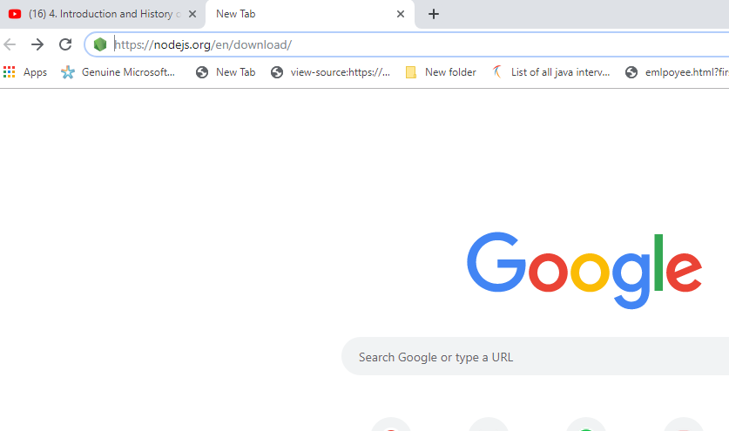

After opening downloads click on windows installer,after clicking it will download automatically,after downloadin click on downlad location and open it.

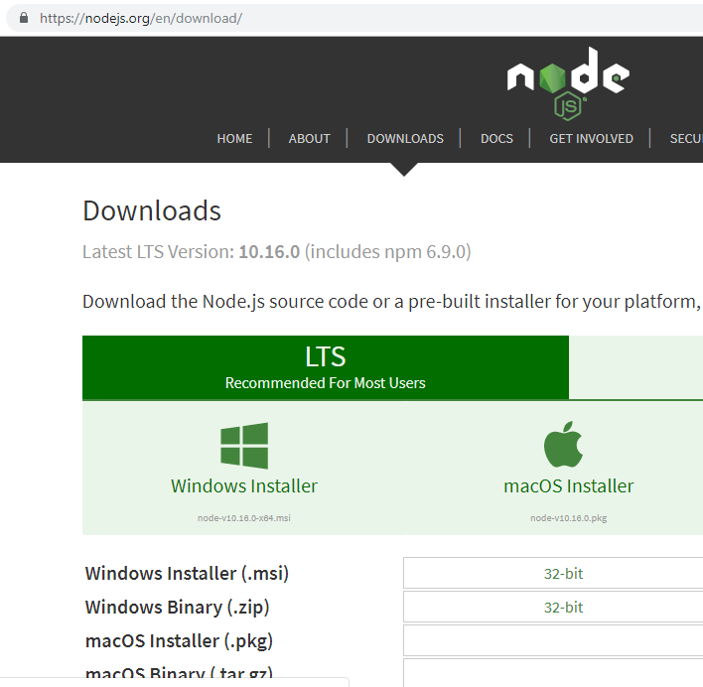

This is the Nodejs file downloaded location,which is downloaded in ‘C’drive/downloads.

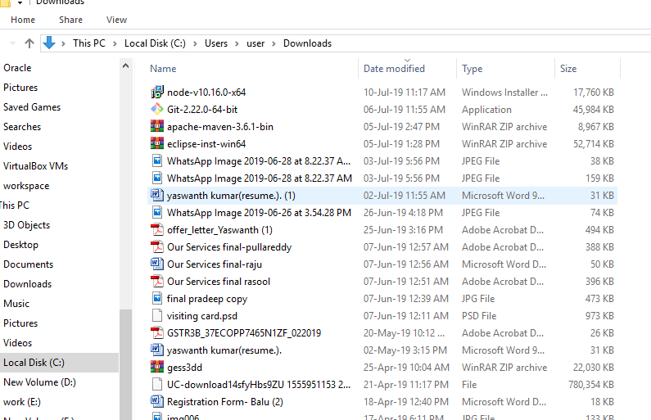

Just give double click on node file then it will open,after click on ‘run’for installation.

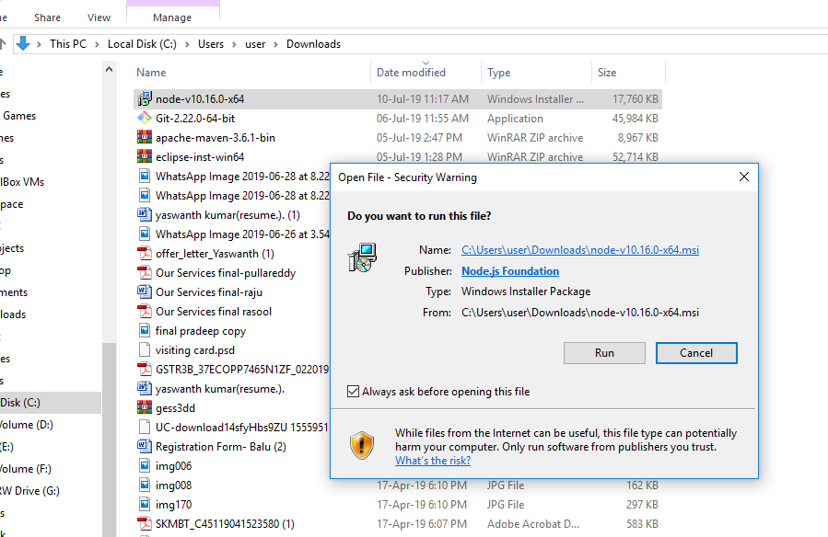

Click on next button to move installation.

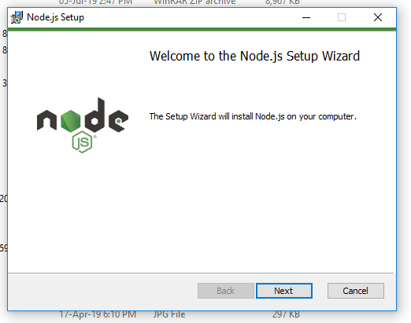

Accept the Node.js license instructions,and click on NEXT.

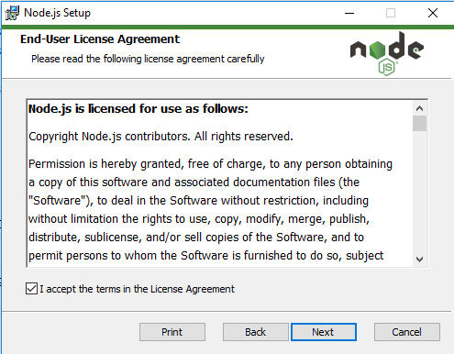

Select the Node.js runtime and click on next.

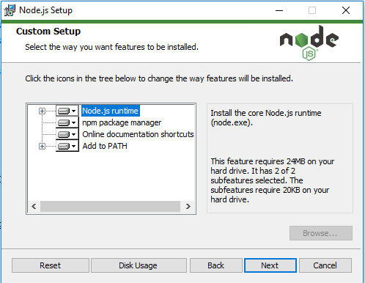

Allocate the location to install Node.js ,this is my nodejs installation location,

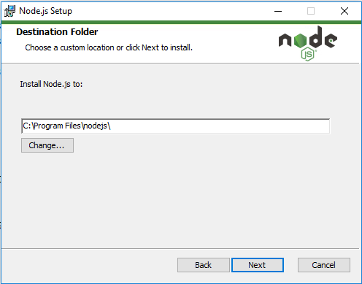

Finally click on install.

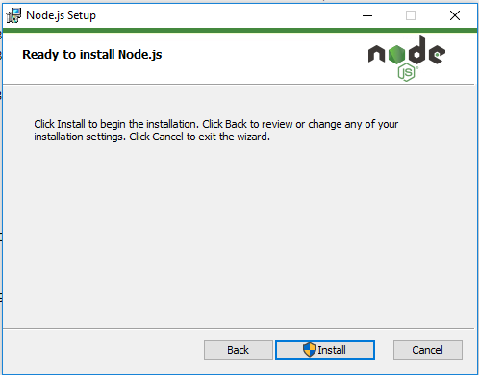

This is the installing process.

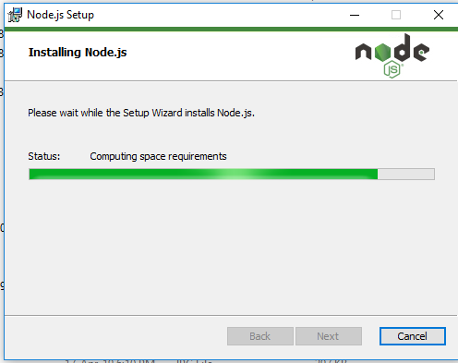

After installing just click on finish.

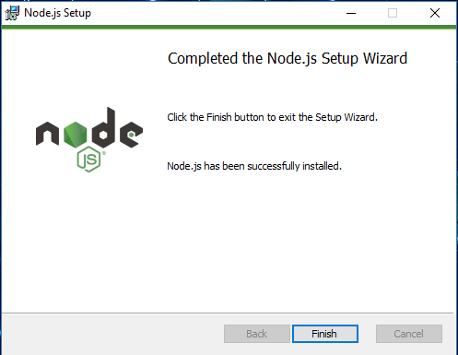

After installing nodejs we have to open command prompt to check the nodejs either installed or not.

*In cmd type the “node -v” for checking nodejs version.

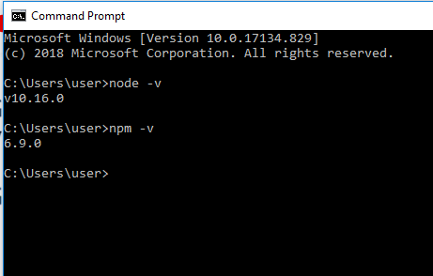

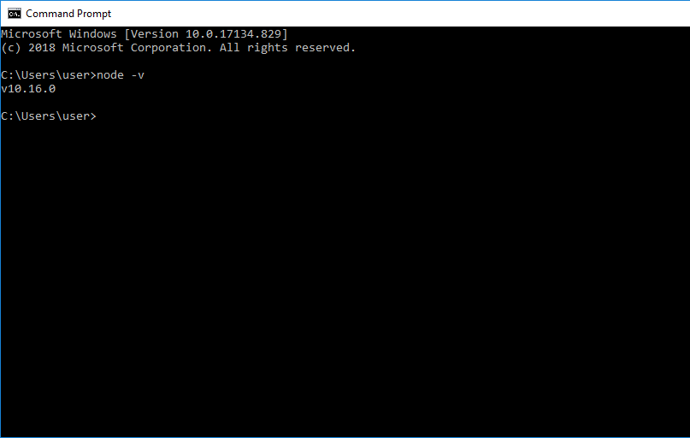

In this we have another tool that is “n p m”, which stands for node package manager, which helps to download open source java script libraries from internet into our system,

When your working with web applications.

*Whenever we install the node npm is automatically installed.



C:\Program Files\nodejs\Angular application> this is our working directory for our angular application as well as typescript.

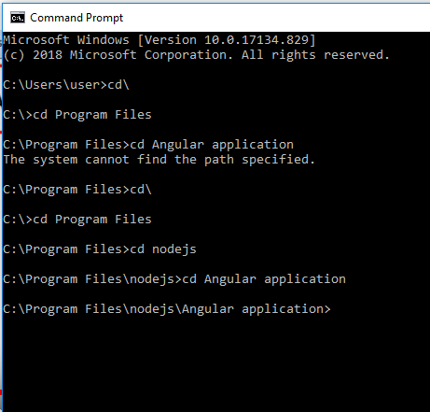

*Through npm im going to install typescript compiller in nodejs by using this command

(npm install –g typescript).

*-g indicates Global installation, so typescript will be available for all the users.

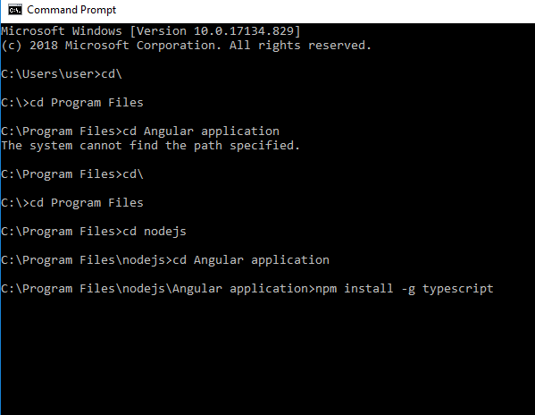

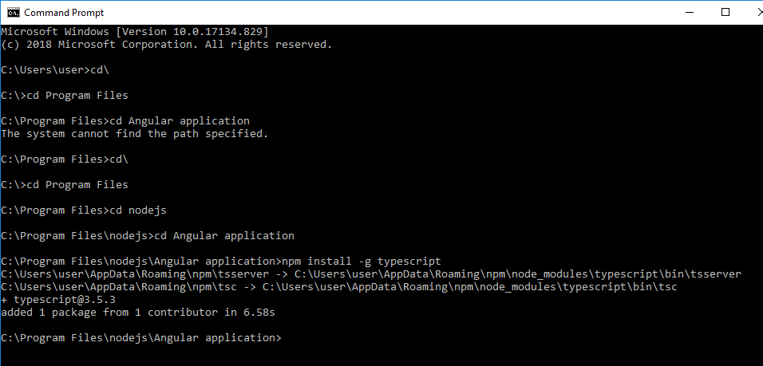

In my system typescript has been integrated into the node.



[typescript@3.5.3](mailto:typescript@3.5.3) which is integrated with node environment in my system.

node modules under typescript\bin it is installed in my system.

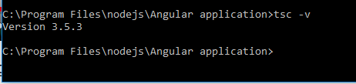

For typescript installation verification we have to use command “tsc -v”

How to install Nodejs ?

*Nodejs Provides Runtime Environment For Angular 8.

* RT Enviroment mean we can Execute our angular programs on Nodejs.

*And similarly as of now Node js is use to run javascripts of typescript,That too(Without any browser).

Editors for typescript Programing.

*Notepad++

*Visual studio code.IDE (Angular also)

( https://code.visualsstudio.com/ )

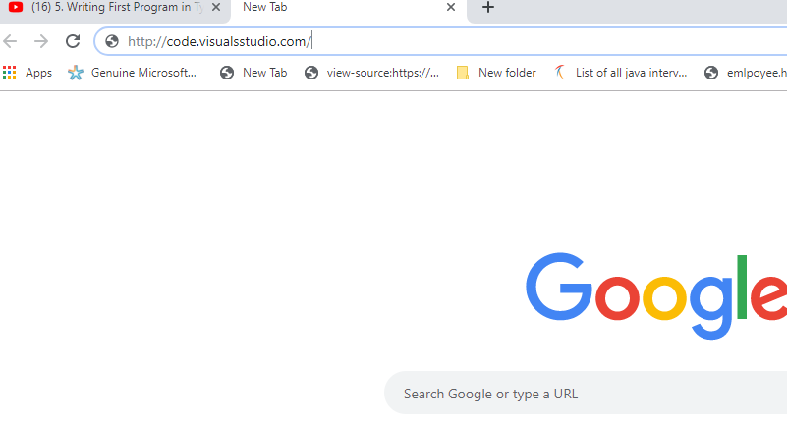

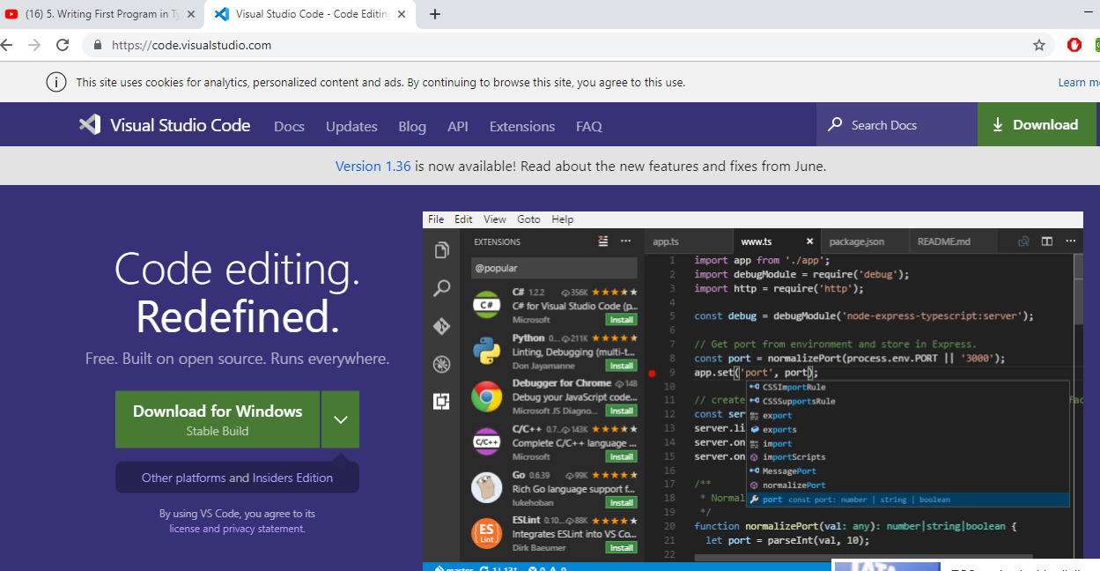

Click on download for windows it automatically detected our operating sysyem.

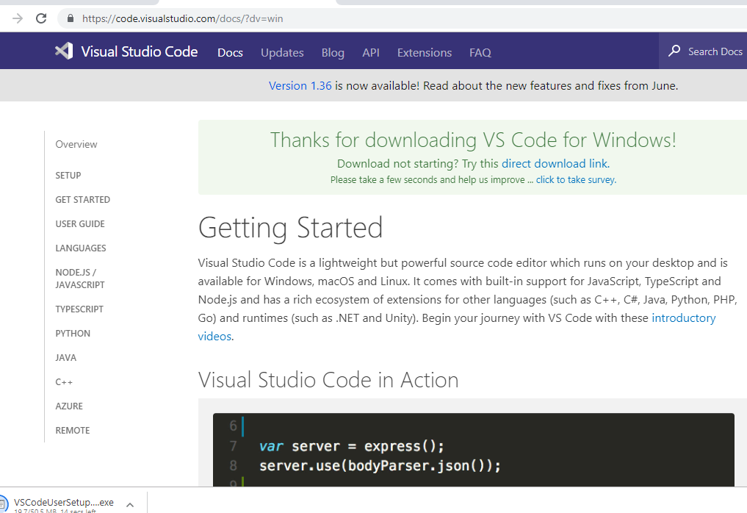

After clicking download yu will get a page like this-🡪 And it will download automticly

This is my “Visual Studio Code” downloaded folder,and Duble click on this visual studio.

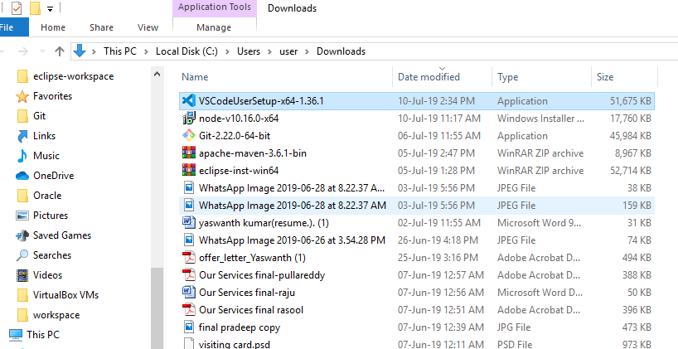

After double clicking I will shows like this Then Run this File.

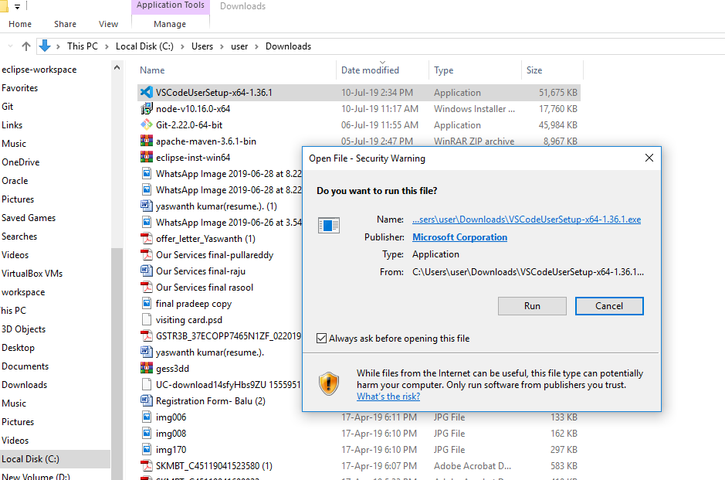  
Accept the Licence agreement.

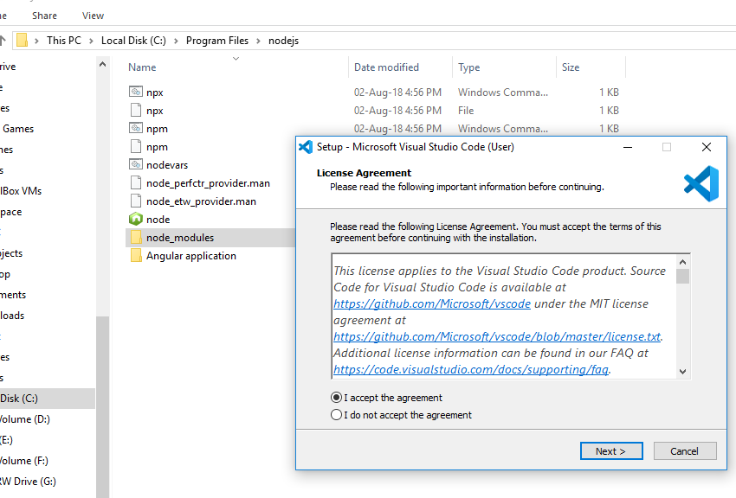

Give the location for insatallation.

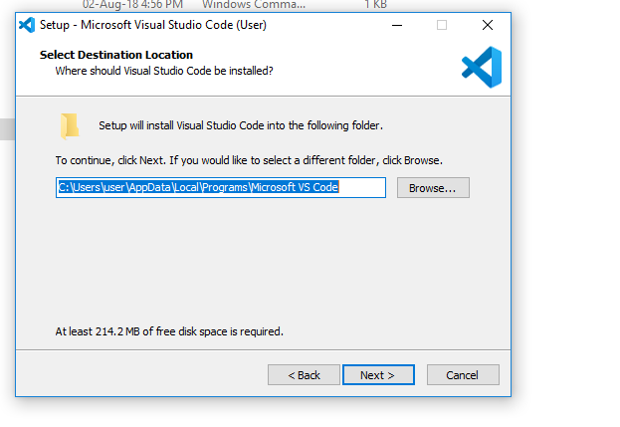

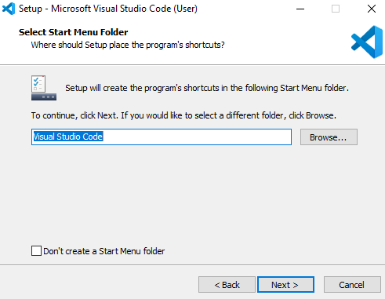

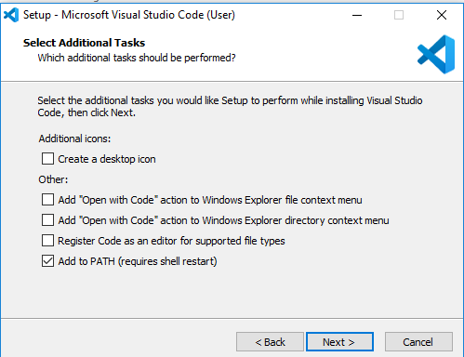

Click on all buttons.

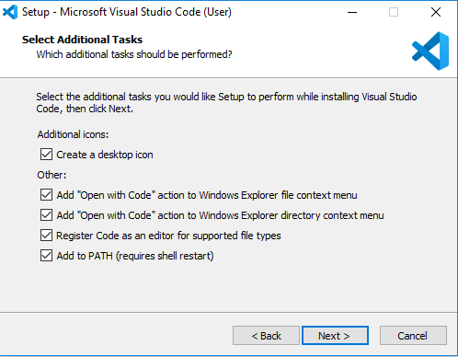

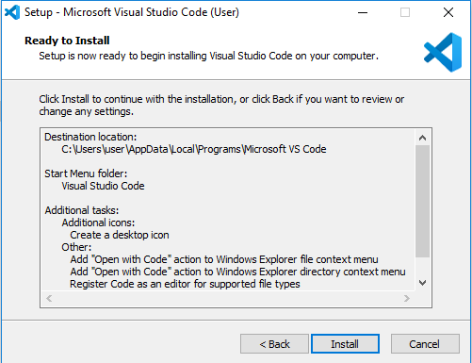

Click on Install, Installing….

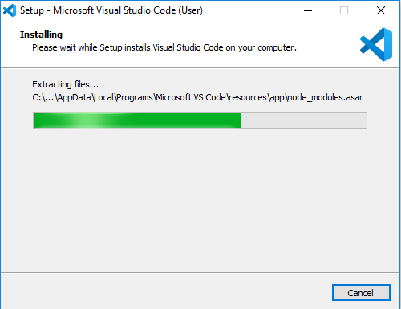

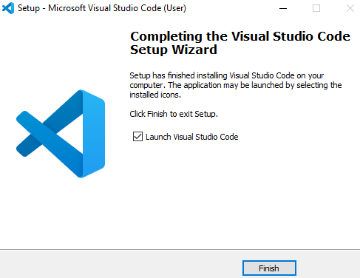

Click on finish.

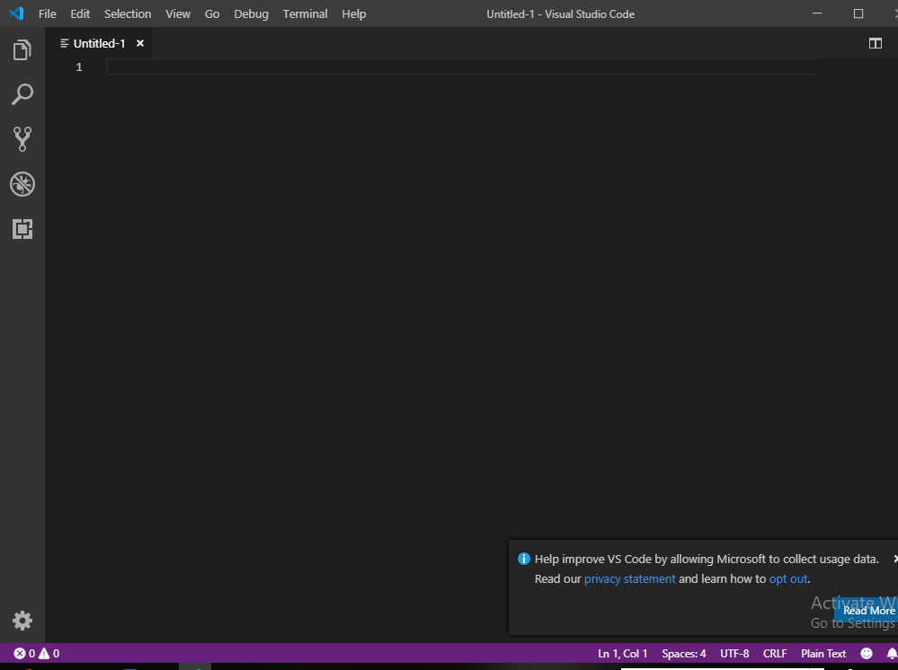

This is the VSC .

How to work with typescriptprograms ?

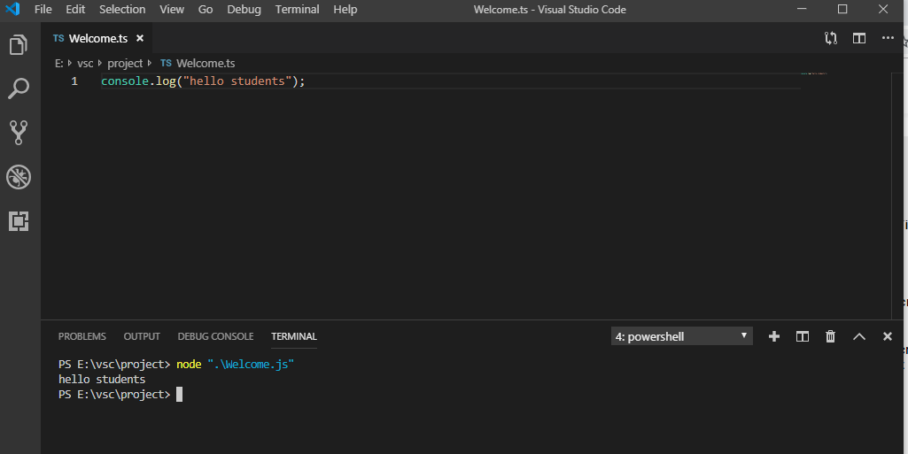

*Open VS Code and take new page and type the program.

For EX:

Console.log(“hello students”);

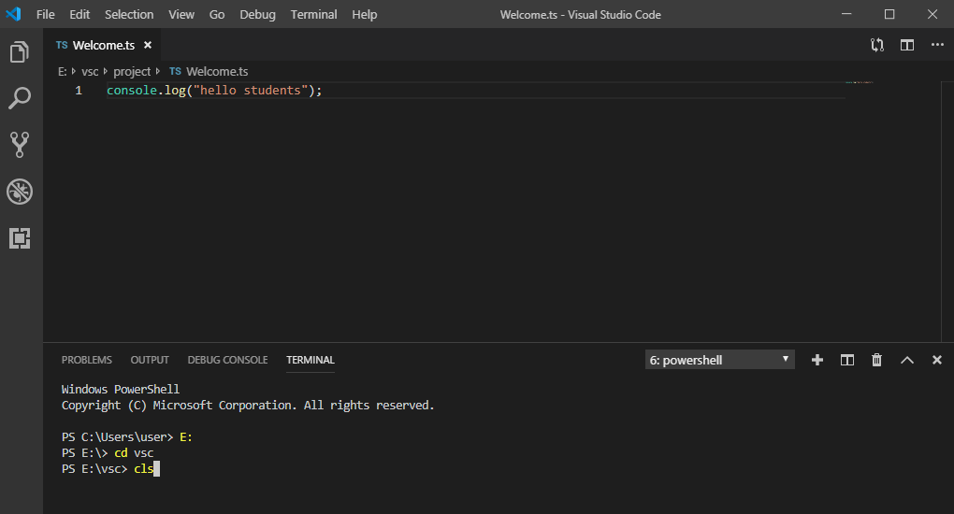

Go to view and click on OutPut,in this it shows terminal we have to click on terminal it will give a command prompt.

After opening CMD go to program location by giving location path.

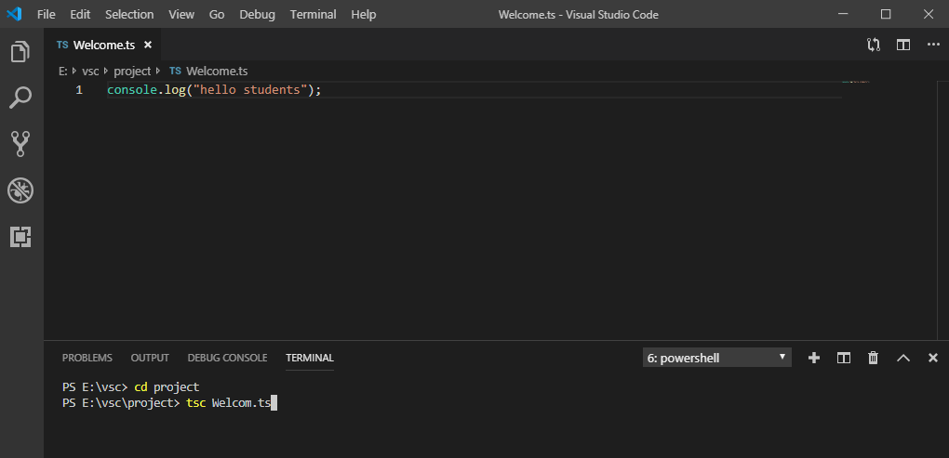

In this “tsc” means typescript compiler,we have to compile the typescript file.

*After compile “ts” file change to “js file”,for that conformation we have to give ”dir”.

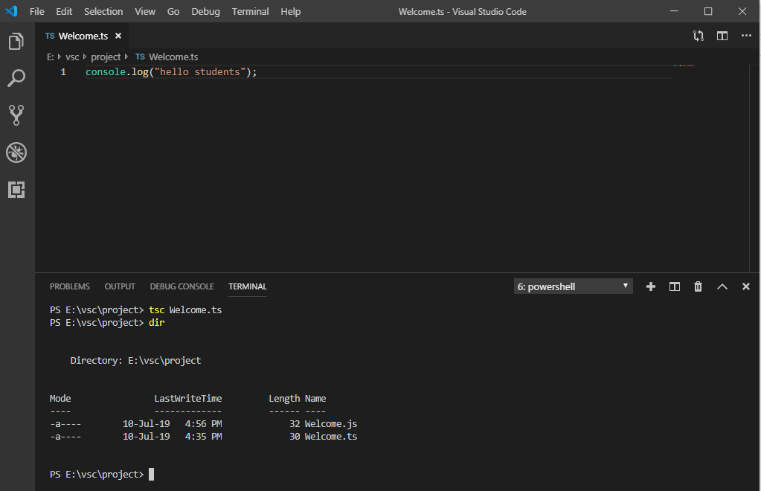

In this showin “ts” file is chsnged to “.js”.

After that Run “.js ”file by using this command ”node Welcome.js”

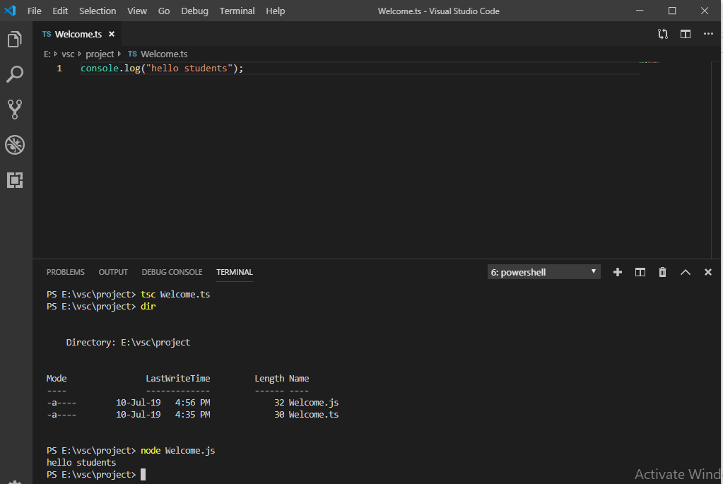

Verify OUTPUT.

We got output without using any Browser.

How to work with notepad++ & Visual Studio code IDE?

Basic And fundamentals of typescript:-

*Comments

*Statements and Expressions

*Variables*Functions

*Modules

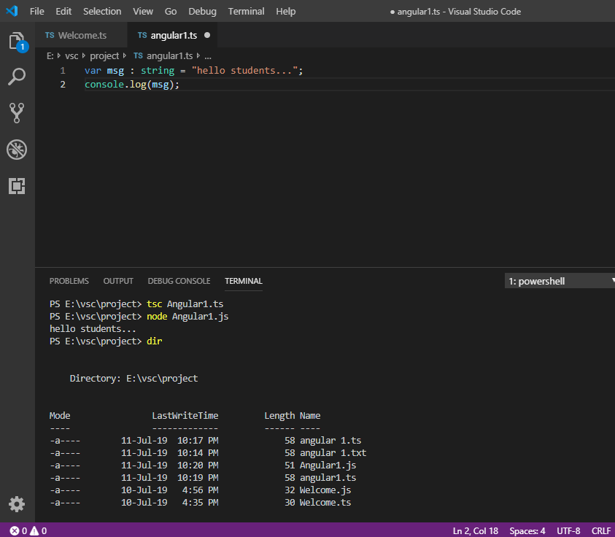

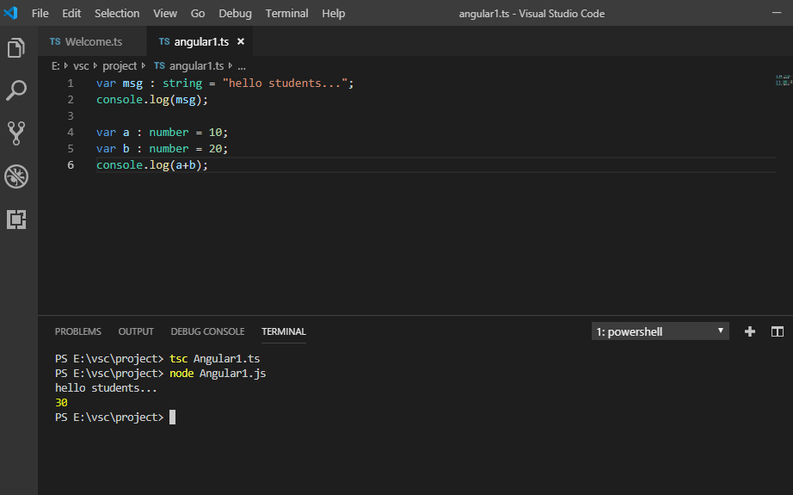

6 Rules for Writing an identifier:-

1)begins only with alphabets(upper/lower)

2)no special charaters except _ or $

3)No keywords as identifiers

4)should be unique.

5)they are case sensitive

6)no spaces in between and use digite at the last

NOTE :-

White spaces and line breaks are ignored while compilation

2)case sensitive language

3)semicolons are opyional (use for multiple stmnt in single line).

** console.log(“…”);

Console means output screen or terminal or command prompt or shelllog(display or put on console).

🡺Comments in typescript ::-

**Provides descripyion of a program

a)single-line comment(//…….)

b)Multi-line comment(/*………*/)

Advantage of comment:

To understanding of program.

🡺OOP’s Programming in typescript :-

*Typescript is OOP

*OOP is base on real world situations

*program with collection of objects and its methods

*Typescript supports the following.

1)Objects (End product used by end-user,it has state-behaviour-identity)

Ex: Mobile-phne

State->Features

Behaviour->usage(calling/sms/internet)

Identity->Apple iphones-X

2)classes(Mode/Prototype/blueprint before creating an actual object)

Model/prototype/blueprint before creating an actual object.

Ex:House-construction(Blueprint)

3)methods(Behaviour of object i.e functionality/uses of end-product).

//Program

(Program to define a class, a method and define its object to call the method)

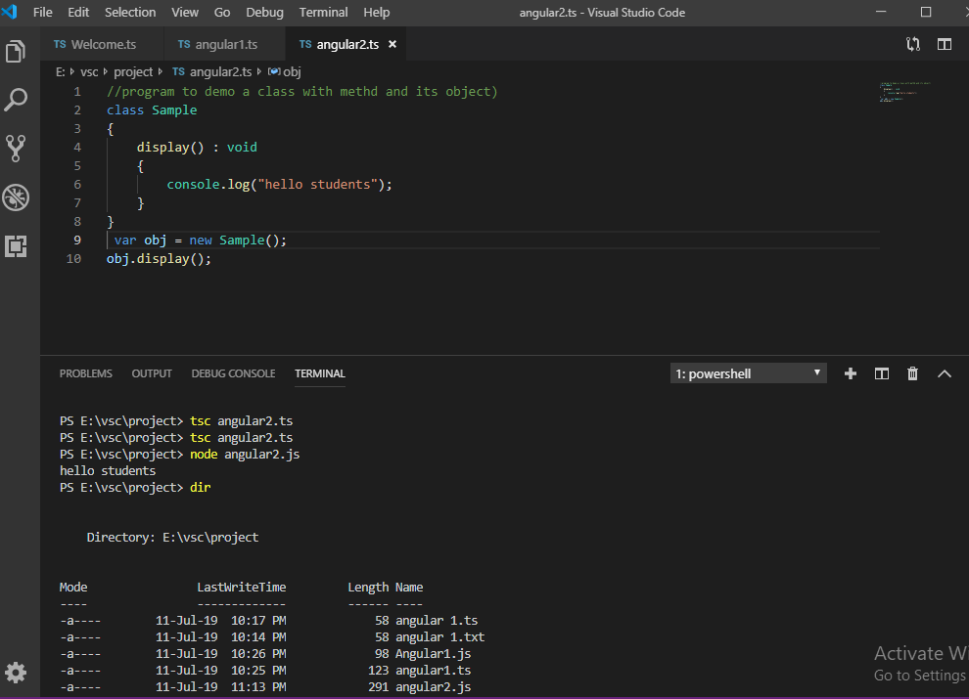

Note:-

*All versions are backward compatible and expected a new version every 6 months.

*In new version some old features would be deprecated(outdated) and added with new library.

**Angular(TS) is based on components and services architecture.where angular js is based on M-V-C Architecture.

*Components are nothing but Classes,and inside this classes will have properties will have functions and will have constructors.

-🡪Enhancements Angular-4/5/6/7/8:

*“if” is supported in angular-2 where as angular-4 onwards supports ”if-else” also

*as keyword in for-loop from angular-4 onwards

*animation package is seprate

(@angular/animation before @angular/core)

*condition based animation disable features

*use <ng-template > instead of <template>

(it is already available in HTML)

*From angular-4 onwards,we require typescript 2.2+.

*pipe titlecase Ex:{{‘Welcome to angular’ | titlecase}}

*http get api is simplified from angular-4 onwards with Httpclient (URL searchparams)

*Small and fast apps*progressive web apps from angular5 onwards.

*material design enhancement from angula6.

Typescript 3.1, Rxjs-6.3,Node10 support from Angular7

*finally angular8, Fast Rebuild Time, template type-checkings,backward compatibility.

1)ENVIRONMENT SETP FOR ANGULAR?

🡪Software Requirements:-

*Nodejs(latest):-

it provide development server for our angular application.

*Npm(latest)(Node package management):-

When we installed Nodejs it will automatically installed in Nodejs,it is a tool to download open source javascript libraries and integrate with our angular application using Nodejs.

*Angular CLI(Latest online install):--

(Command Line Interface)(https:/cli.angular.io)

Using commands we create our project application files and folders in our system for development

For EX:- if you take Eclips and Visual Studio Code and NetBeans in we have everything in the form of GUI.Like that only Angular CLI helps us to project development.

(For this Angular CLI installation I DID A ONE DOCUMENTATION)

*IDE for writing your code(Visual studio code)

2)PROJECT SETUP FOR ANGULAR?

3)CREATING FIRST ANGULAR-APPLICATION?

🡪 Ng new first-app(FirstApp)

🡪ng new is the command

🡪Create anew angular app

🡪it creates complete folder structure for our Angular-app.

🡪Angular-app folder structure is created in our working directory

Cmd> first-app(FirstApp)

Cmd\first-app(FirstApp)>ng serve

4)Why Angular When Compared to AJS?

*5Times faster compare to AJS.

*Angular is Modular programming,in this angular we write everything in the form of modules, components and services.

This modular programming is followed in server-side progrmming like java ,.NET ,python.

Modular programs helps us to develop projects very flexible as per latest hdlc life cycle Ajoy life cycles.

*Angular js is a M-V-C Architecture.

*Angular is the application platform:--

Application platform means we can integrate multiple UI Technologies and Develop the web Application,we can integrate multiple technologies into the single web application development.

Angular js is only Javascript and itself integrated in other server side web application.

*Scripting Lang Options.

(Typescript, Purescript, Dart, EIM etc)By using this we can develop Angular.

*Unit testable:-

Basically whenever you developed any application that application has to be tested by quality analyst and testing engineers,But before that developer has to do unit testing.

Angular applications are fully compatible with unit testable applications.

*We can use angular provided modules and packages for testing our applications.

Creating Angular Applicaton ?

Creating first application in Angular :-

** ng new is the command

*It creats the new Angular application,it create complete folder structure for our Angulae-app

*Angular application folder structure is created in our working directory.

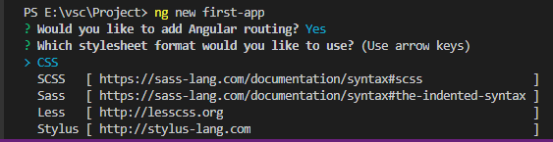

When you enter ng new command it will asks you to want which typescript ?

* Standard css is supports for all webapplications as per www.

*So click on CSS,it will create complete folder structure in our angular application.

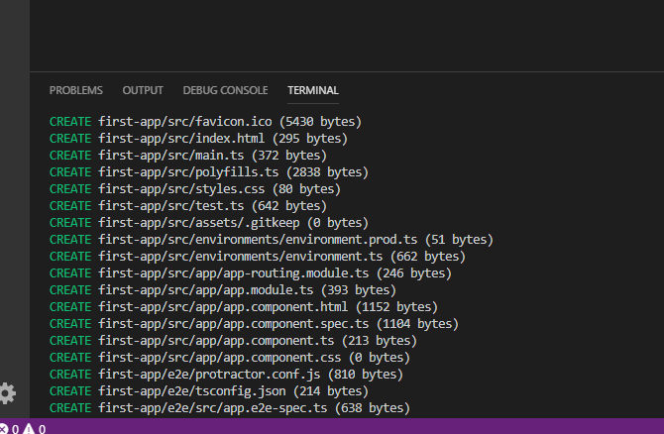

Added 1078 packages from 1047 contributors and audited 17110 packages in 222.769s found 0 vulnaerabilities.

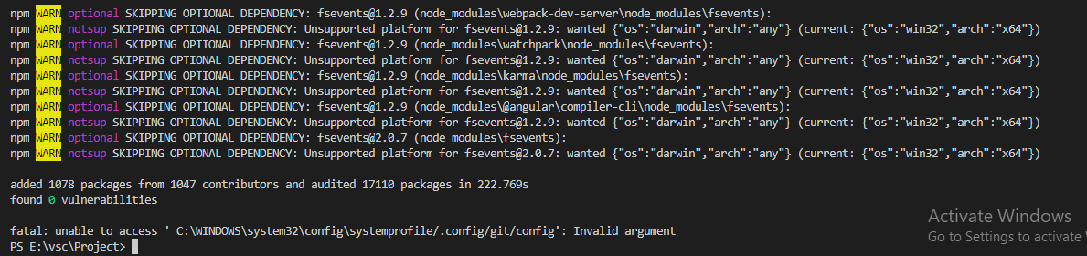

Go to my computer and open work directory.in that we can see our first-app.

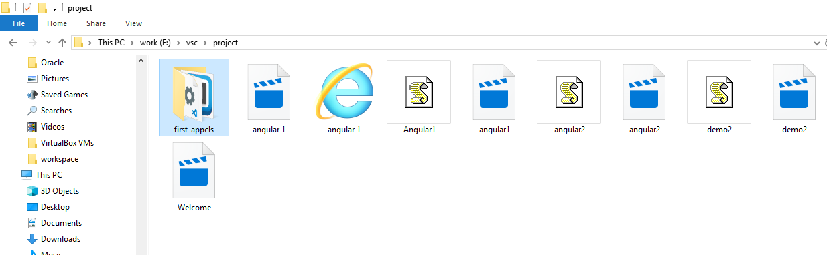

Click on first-app folder,in this important folders will be there they are:

1)e2e(end to end) :-this is not necessary.

2)node-modules :-(here we will have all packages for our application development)

3)src :-( we are going to work with our logic under this src)

4)package.json :- (will give information about the different packages whichpackages are available in our application).

5)Karma.conf :-(which less you to write your testscript and allthose things testscript related configuration using javascript )

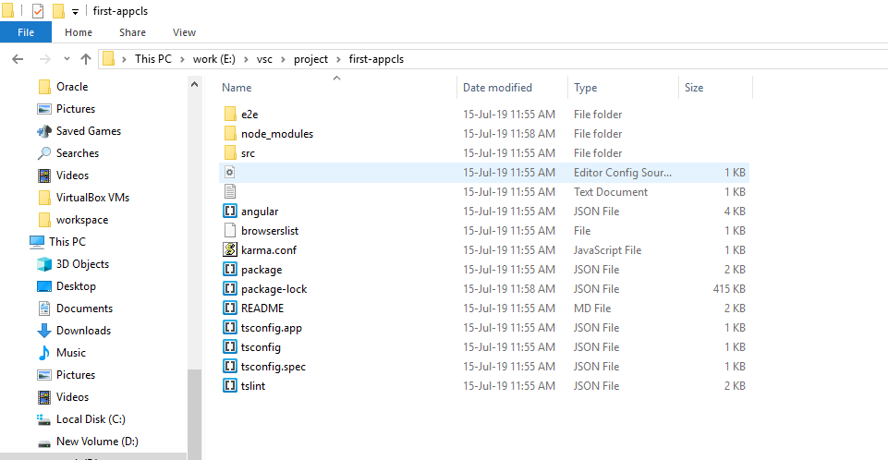

Just try to open first-app in VSC :-

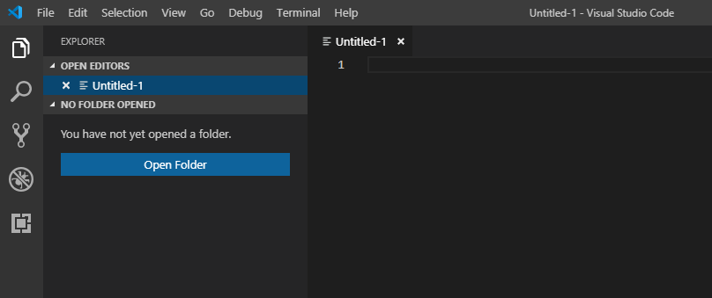

Click on explorer here we have working directories available here,after click on file and open folder

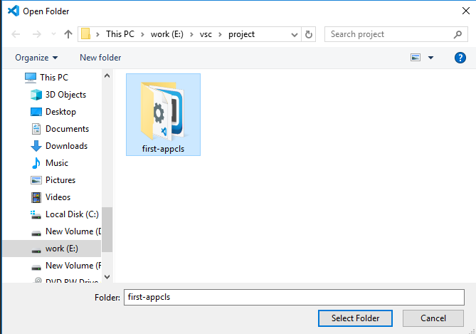

After selecting folder VSC will be reloading that completely in this explorer,We can see the same folders in First-application

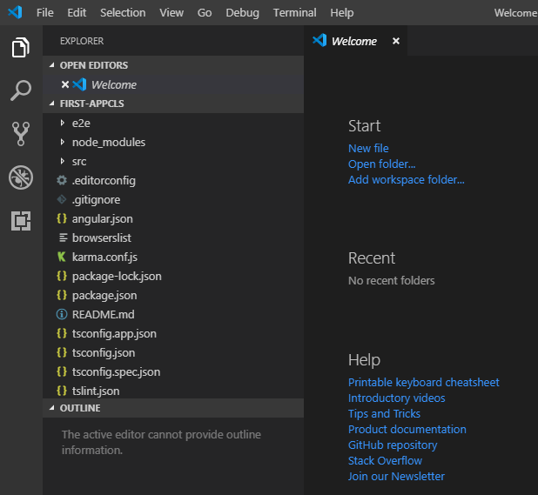

Click on package.json here we can see different type of packages which are get in use our application.

Animation, common, core etc……..

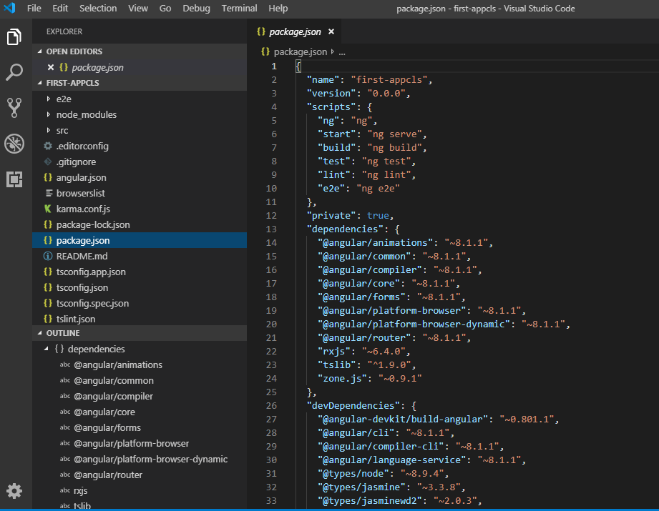

All this packages are available in node_modules folder,this packages starts with @ symbole.

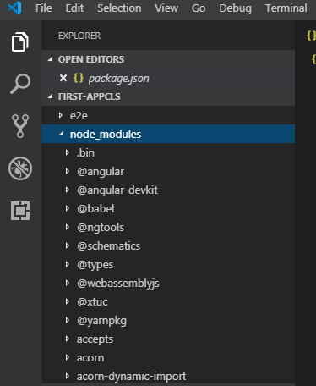

After coming to “src” folder:-

In this very important file main.ts,index.html and then our working directory “app”,in that app have app.module.ts and app.component.ts and app.component.html and app.component.css.

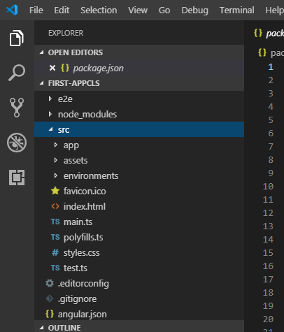

This are some important files for working with our angular first-application.

Open terminal and see in this already open our first application.

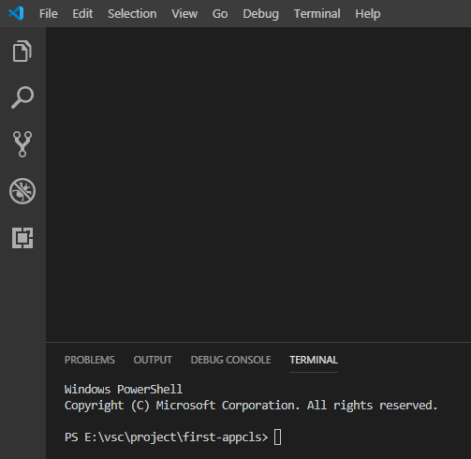

After that run our application on angular life development server which is provided by using “ng serve”.

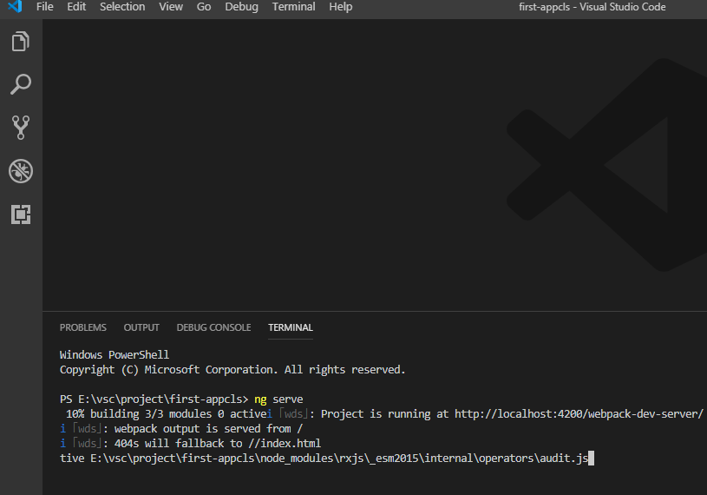

Its compiling our application it means all over typescript its converted into javascript

Our project will be running under this port number http://localhost:4200/webpac-----------

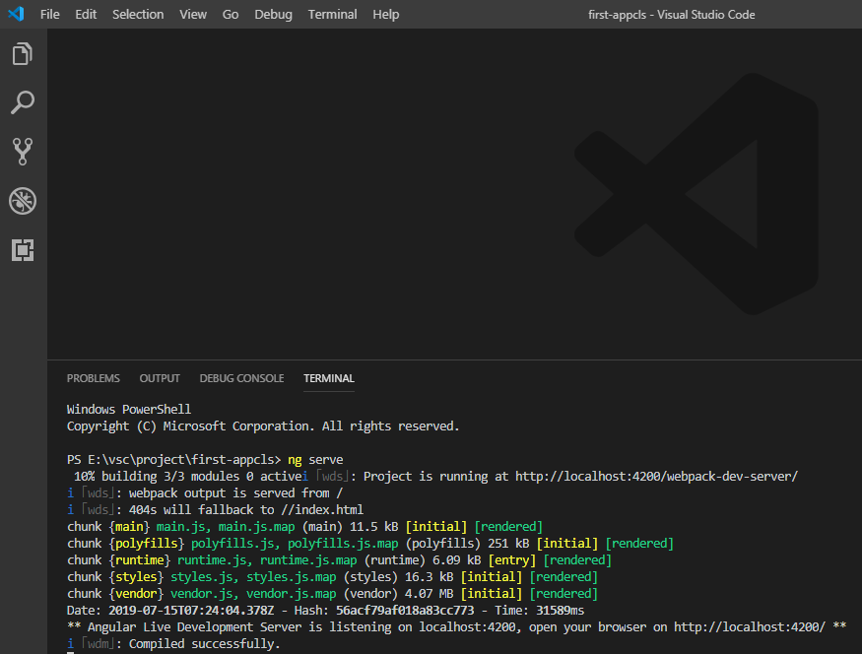

It has compile successfully

Its giving another messge here is angular live development server is listening on local host [http://localhost:4200/**](http://localhost:4200/**).

After that im going to open browser and im giving local host in browser.

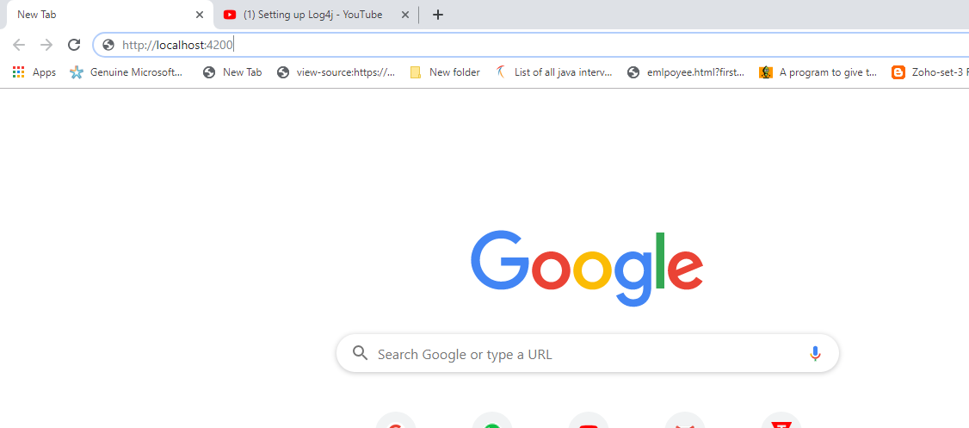

Then we can see our first-app in website.

